The Loop Cut Tool

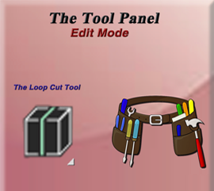

# Loop cut Button Verses the Hot Key

You have more control over this tool, if you use the hot key. When you use ctrl-r to create a loop cut, you can then roll the middle mouse wheel, and you can create multiple loop cuts. I haven’t been able to do this same action, when coming into this tool, by clicking to loop cut tool button in the tool box.